Title of the Abstract for National Conference on Upstream Petroleum Engineering 2019 (NCUPE 2019)
First Author¹, Second Author², and Third Author³
1 Author’s Department, Institute, City, State, Pin code
2 Author’s Department, Institute, City, State, Pin code
3 Author’s Department, Institute, City, State, Pin code
Corresponding Author’s Email Id: xxxxxx@xxxxx.xxx
Keywords: Up to 7 words arranged in alphabetical order.
Extended Abstract
Format: The abstract should be written in MS Word. Use A4 page set-up and make all margins 2.5 cm wide. The title is centered, bold Times New Roman 14pt, authors names are centered, in bold Times New Roman 12pt, and affiliation is Times New Roman 12pt (not bold). The email address of the presenting author must be provided. The heading should be left aligned in bold faced 12pt. There should be a space before and after the headings. The body text must be written single spaced justified in Times New Roman 12 pt. (not bold).
Length of the Extended Abstract should be 2 pages
Figures & Tables: All the tables and figures should be numbered and captioned. The caption should be centered, with sentence case letters. A sample table and figure are as shown below:

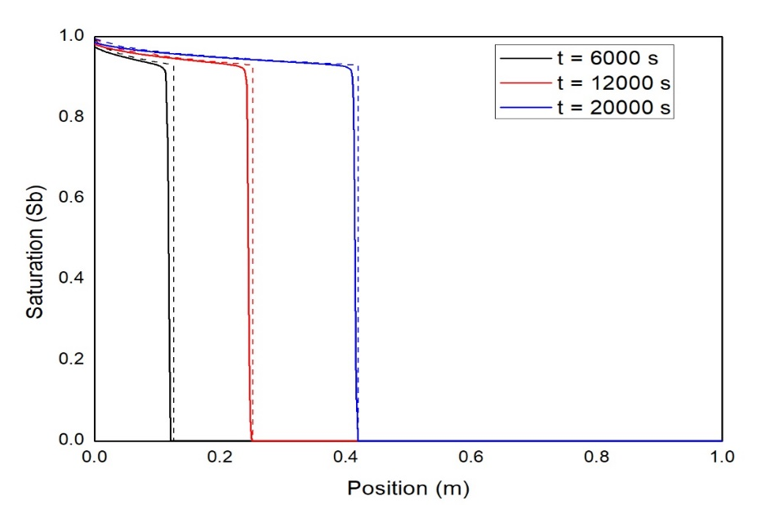

Figure 1: Validation of IMPES solver using Brook-Corey model
Fluid | Density (kg/m³) | Viscosity (Pa.s)
Air | 1 | 1.76 × 10⁻⁵
Water | 1000 | 1 × 10⁻³
Oil | 800 | 1 × 10⁻¹

Table 1: Properties of fluid
Content: Explain the aim & objective of your study, material and methods used, results and discussion and conclusion reached.
Acknowledgement: Authors would like to thank…
References: Cite references in the text (inline citations) or in figure or table captions by placing the author’s last name and the year of publication in parentheses. Examples: Single author-(Smith 1980), more than one author: (Brooks et al. 2011). References included in the same set of parentheses should be separated by semicolons (Smith 1980; Brooks et al. 2011).
Citing reference in references list: Reference should be arranged in alphabetical order as per the format below:
Author, A. and Author, B. YEAR. Title of article. Journal Vol (Issue): pp-pp. DOI.
Example: King, M. J. and Mansfield, M. 1999. Flow Simulation of Geologic Models. SPE Res Eval & Eng 2 (4): 351–367. http://dx.doi.org/10.2118/57469-PA.

